Remark + Changes "Our Counselling Services"
Attention: In the mobile view, the headings are truncated or displayed separately. Please correct

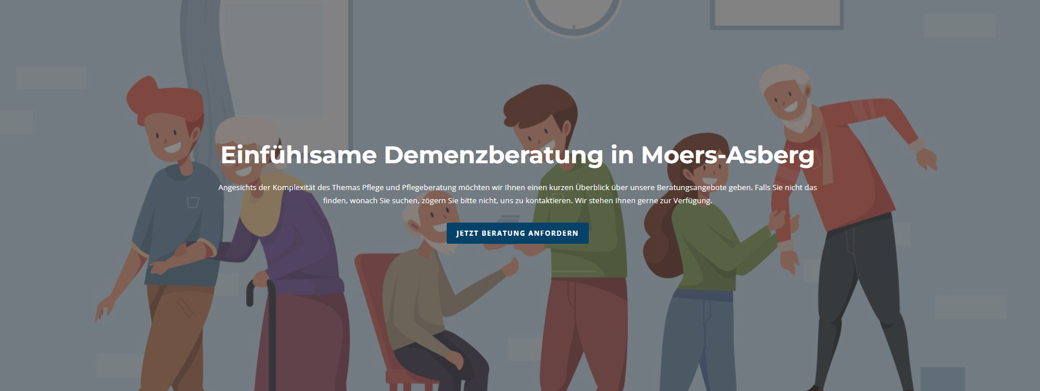
Remark:
- Change title – "Empathetic care advice in your area"
- Adjust font size (the target audience is the elderly)
- Link "Request advice now" does not work

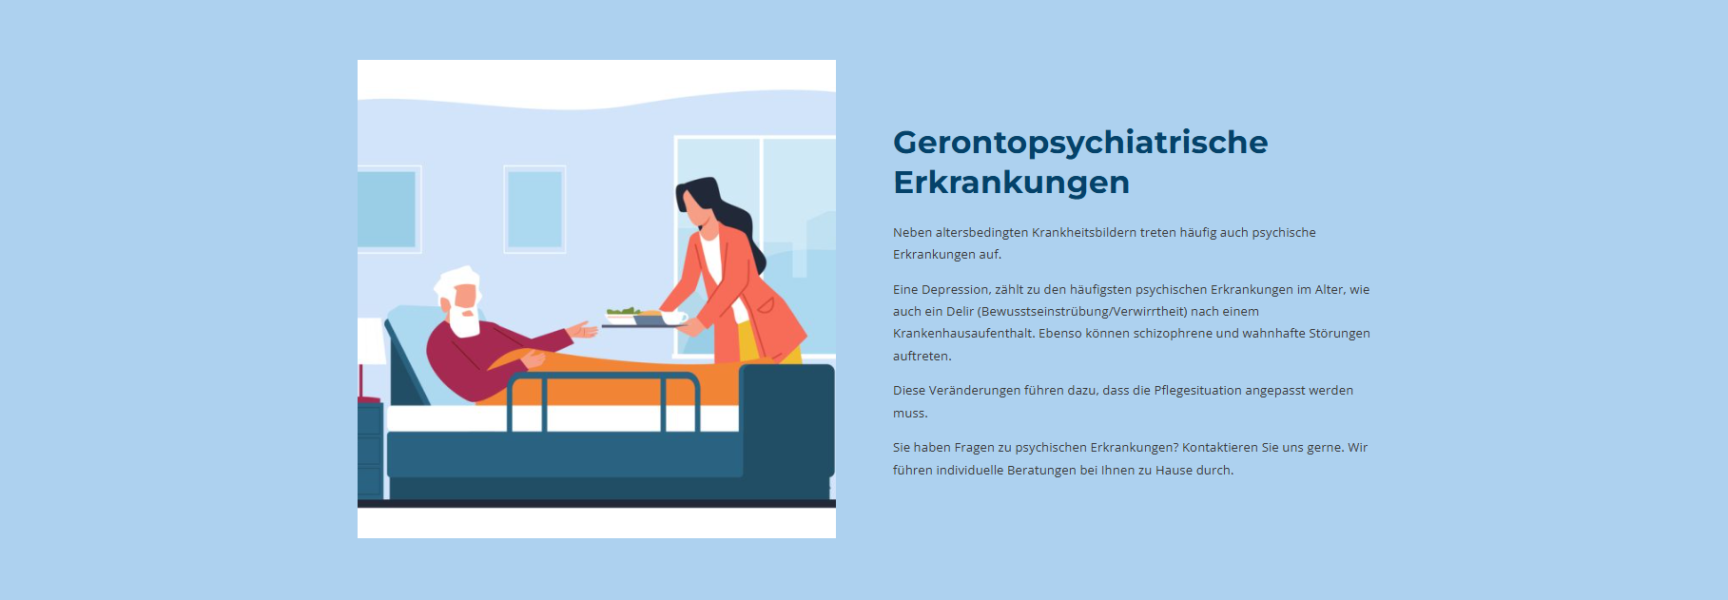
Remark:
- Adjust font size (the target audience is the elderly)

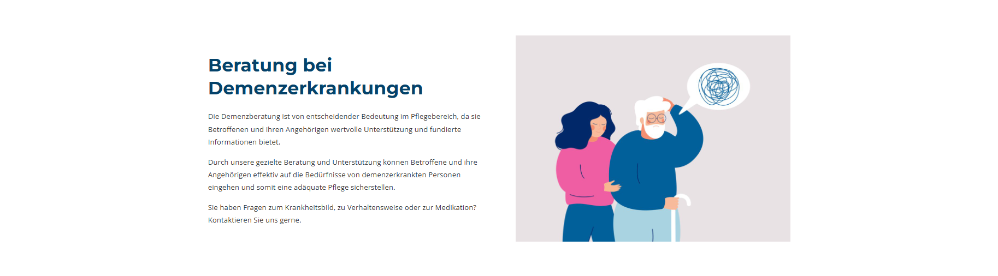
Remark:
- Adjust font size (the target audience is the elderly)

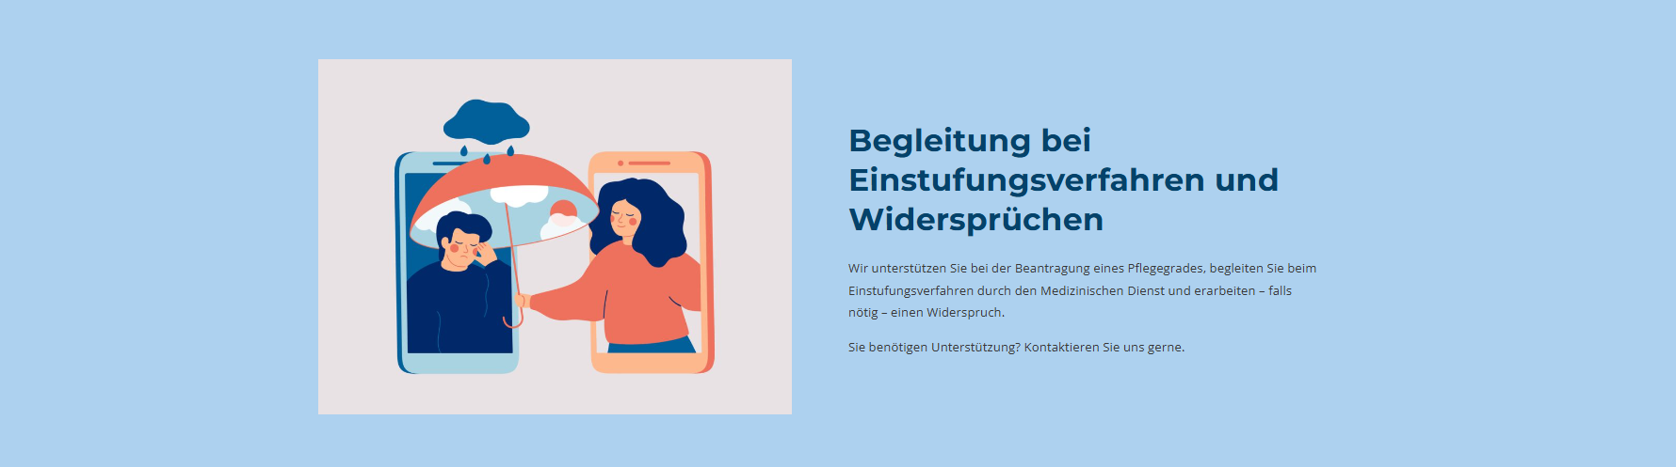
Remark:
- Adjust font size (the target audience is the elderly)

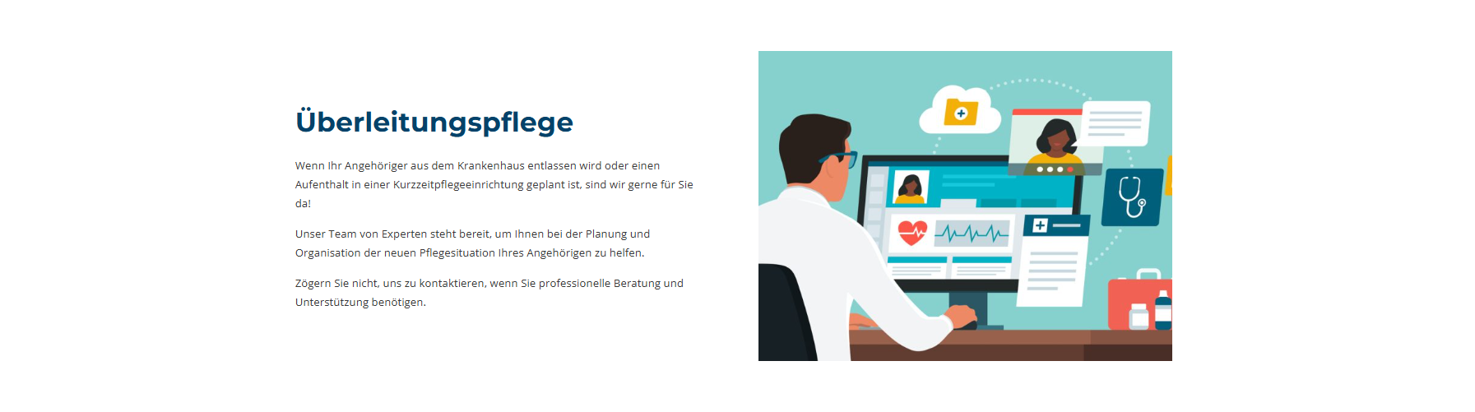
Remark:
- Adjust font size (the target audience is the elderly)


Remark:
- Adjust font size (the target audience is the elderly)

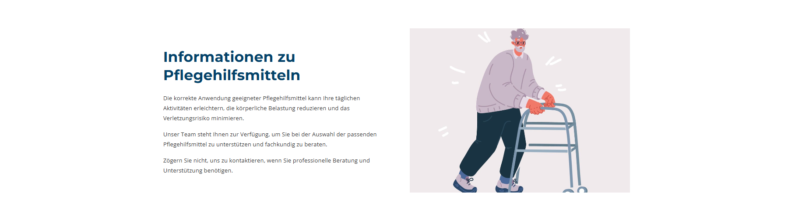
Remark:
- Adjust font size (the target audience is the elderly)

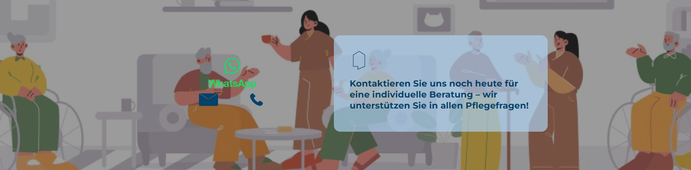
Remark:
- WhatsApp logo should move along
- Email icon and phone icon in the box? Currently very poorly visible

